Nama: Michael Dimas Chrispradipta
NIM: 2602132154
DOKUMENTASI dan REFERENSI AOL HCI
- Dokumentasi & Referensi
  - Homepage
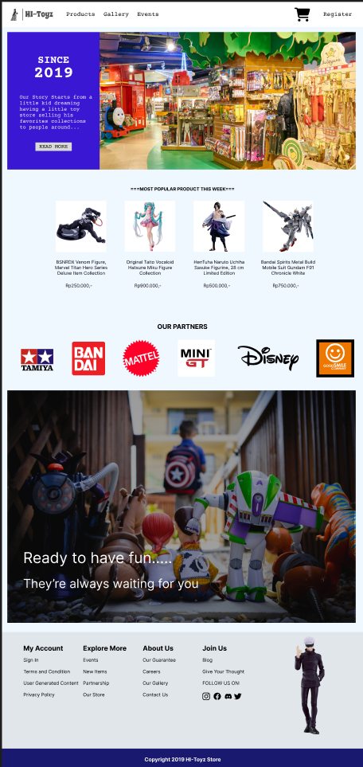
Dimulai dengan Header yang berisi menu menuju halaman tertentu, melihat keranjang dan registrasi, halaman awal dari website HI-Toyz store ini berisikan cerita singkat sejarah berdirinya HI-Toyz yang bisa dilihat detailnya saat user menekan button ‘READ MORE’. Di samping itu, Homepage juga menampilkan produk-produk yang paling banyak diminati/dibeli dalam pekan itu yang kemudian dilanjutkan dengan menampilkan logo-logo company yang bermitra dengan HI-Toyz. Ke bawah lagi, akan ada selingan dengan gambar dan tagline dan Homepage diakhiri dengan footer.

Referensi Media:
    - Toy Store Room: https://travellersworldwide.com/wp-content/uploads/2022/05/shutterstock_744862012.jpg
    - Venom: https://m.media-amazon.com/images/I/61Jz4qjl3KL.jpg
    - Hatsune Miku: https://ae01.alicdn.com/kf/Sffce9293b0914ea4be8954293c85a3bf8/In-Stock-Original-Taito-Vocaloid-Hatsune-Miku-Action-Figure-Collection-22Cm-Anime-Kawaii-Doll-Model-Collectible.jpg
    - Sasuke: https://m.media-amazon.com/images/I/515xp2KWJqL.jpg
    - Gundam: https://m.media-amazon.com/images/I/81AflUXvVYL._AC_UF894,1000_QL80_.jpg
    - Logo Tamiya: https://upload.wikimedia.org/wikipedia/commons/thumb/8/8c/Tamiya.svg/2560px-Tamiya.svg.png
    - Logo Bandai: https://upload.wikimedia.org/wikipedia/commons/0/0f/BANDAI_logo.png
    - Logo Mattel: https://upload.wikimedia.org/wikipedia/commons/thumb/7/7b/Mattel_%282019%29.svg/1200px-Mattel_%282019%29.svg.png
    - Logo MiniGT: https://cdn.shopify.com/s/files/1/0756/3598/2685/collections/mini_gt_logo_68a888be-ce0e-4d22-8283-29ab582cb07c.webp?v=1684611734
    - Logo Disney: https://upload.wikimedia.org/wikipedia/commons/thumb/a/a4/Disney_wordmark.svg/2560px-Disney_wordmark.svg.png
    - Logo GoodSmile: https://cdn.shopify.com/s/files/1/0623/1349/6801/collections/GoodSmile.png?v=1648165153
    - Toy Story: https://images.unsplash.com/photo-1599623560574-39d485900c95?ixlib=rb-4.0.3&q=85&fm=jpg&crop=entropy&cs=srgb&dl=chris-hardy-H5Ffv4I5ZMI-unsplash.jpg
    - Gojo Satoru: https://imgs2.goodsmileus.com/image/cache/data/productimages/Figmas/SatoruGojo/01-1200x1200.jpg

  - Products Page
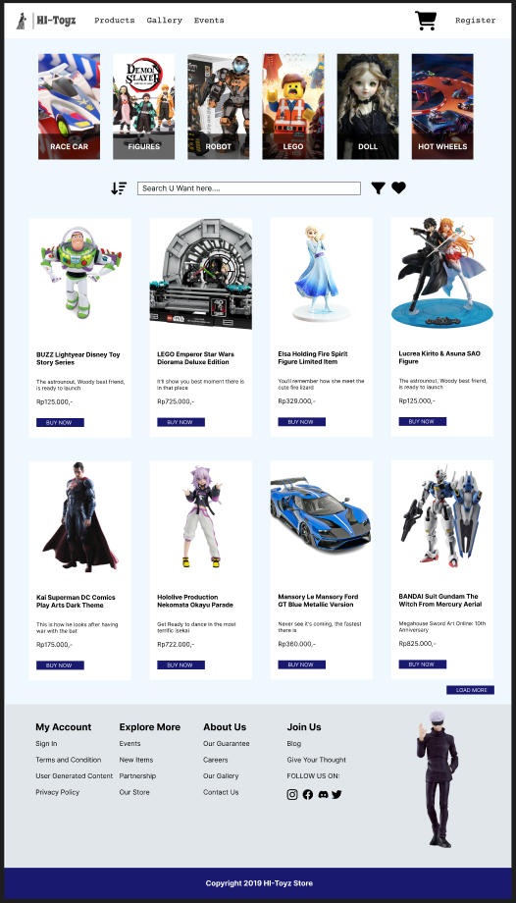
Di Products Page, setelah header, akan ditampilkan kategori-kategori mainan yang dijual. Di bagian bawahnya terdapat search bar di mana user bisa mencari produk, sort icon di mana user bisa mensorting produk berdasar kondisi tertentu, filter icon di mana user bisa menyeleksi produk serta heart icon di mana user bisa melihat list produk yang menjadi favoritnya. Kemudian dilanjutkan dengan beberapa produk-produk yang direkomendasikan dengan button Buy Now untuk membeli dan button Load More untuk lebih banyak produk.

Referensi Media:
    - Tamiya: https://wallpapercave.com/wp/wp11655482.jpg
    - Demon Slayer: https://id-test-11.slatic.net/p/4fab6fbbce1bc19e2fa55b36f599388d.jpg
    - Robot: https://www.ubuy.co.id/productimg/?image=aHR0cHM6Ly9pbWFnZXMtY2RuLnVidXkuY28uaWQvNjMzZmVkNjdiZjMwZWYwYTEwNmJjMzhiLXJvYm90LXRveXMtZm9yLWtpZHMtYWdlcy01LTYtNy04LTktMTAuanBn.jpg
    - Lego: https://images8.alphacoders.com/476/476260.jpg
    - Doll: https://wallpapercave.com/wp/wp2562321.jpg
    - Hot Wheel: https://images.hdqwalls.com/download/hot-wheels-unleashed-oc-2048x2048.jpg
    - Buzz: https://i5.walmartimages.com/asr/9cfb0923-5bcb-4d6d-ae5c-5a9ae7cbe6cc_1.da24db494419ec069c1d80a9dd06076b.jpeg
    - Lego Emperor Diorama: https://www.google.com/imgres?imgurl=https%3A%2F%2Fwww.lego.com%2Fcdn%2Fcs%2Fset%2Fassets%2Fblt92ae31f4d0259d50%2F75352.png&tbnid=BLycA1UPDbvBCM&vet=12ahUKEwjswLG17K7_AhUBNLcAHeF4AU4QMygAegUIARClAQ..i&imgrefurl=https%3A%2F%2Fwww.lego.com%2Fen-us%2Fproduct%2Femperor-s-throne-room-diorama-75352&docid=muic39rBun9niM&w=2400&h=1800&q=lego%20emperor%20diorama&ved=2ahUKEwjswLG17K7_AhUBNLcAHeF4AU4QMygAegUIARClAQ
    - Elsa: https://ae01.alicdn.com/kf/S1621dc44a6db4781b5752dd11049b5d5r/21Cm-Disney-Frozen-Snow-Queen-Elsa-Princess-Memegang-Naga-Api-Di-Tangan-PVC-Action-Figure-Anime.jpg_Q90.jpg_.webp
    - SAO: https://m.media-amazon.com/images/I/61llMfCchUS.jpg
    - Superman: https://cdn11.bigcommerce.com/s-lyvo1qtroi/images/stencil/1280x1280/products/78278/205025/STL003992__34743.1663951338.jpg?c=2?imbypass=on
    - Nekomata: https://www.sukipan.com/images/product_images/original_images/x_gsc94399.jpg
    - Mansory Le Mansory: https://4kwallpapers.com/images/wallpapers/mansory-le-mansory-ford-gt-white-background-2020-5k-8k-8577x5722-3066.jpg
    - Gundam: https://d3nt9em9l1urz8.cloudfront.net/media/catalog/product/cache/3/image/9df78eab33525d08d6e5fb8d27136e95/4/5/4573102639943_-_robot_spirits_side_ms_gundam_aerial_veranime_11_.jpg
  - Gallery Page
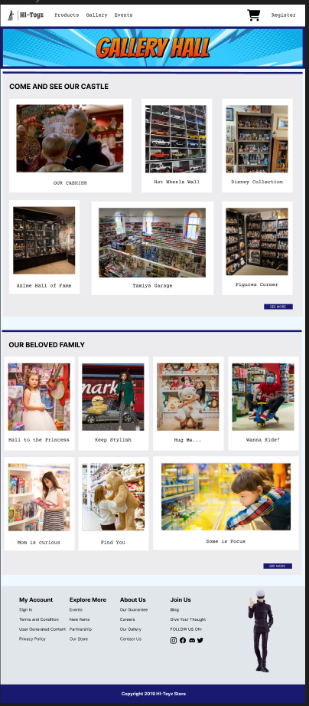
Di awali dengan judul “Gallery Hall” dengan background biru, page ini berisikan foto-foto bagian store dan moment-moment pelanggan HI-Toyz Store. User juga dapat melihat lebih banyak foto dengan menekan button SEE MORE.

Referensi Media:
    - Cashier: https://www.thesun.co.uk/wp-content/uploads/2022/11/OP_LY_HOME-ALONE-2.jpg?strip=all&quality=100&w=1920&h=1080&crop=1
    - Hot Wheel Wall: https://i0.wp.com/lamleygroup.com/wp-content/uploads/2021/01/DSC_0021.jpg?ssl=1
    - Disney Collection: https://www.carol-anne.ca/images2/0036_DisRm_2020.jpg
    - Anime: https://preview.redd.it/maakies-figure-collection-room-tour-2022-anime-manga-game-v0-0jyacurg8dia1.jpg?auto=webp&s=5a2abab144fbd5565755fb3d5103f88019c5a58a
    - Tamiya Garage: https://northeastmodelcentre.co.uk/wp-content/uploads/2020/10/north-east-model-centre.jpg
    - Figures Corner: https://i.ytimg.com/vi/TAbBlOxIekQ/maxresdefault.jpg
    - Princess: https://images.pexels.com/photos/8554774/pexels-photo-8554774.jpeg?cs=srgb&dl=pexels-%D0%B5%D0%BA%D0%B0%D1%82%D0%B5%D1%80%D0%B8%D0%BD%D0%B0-%D0%BC%D1%8F%D1%81%D0%BE%D0%B5%D0%B4-8554774.jpg&fm=jpg&_gl=1*8lxy9q*_ga*MTg1NjI5MDgzNy4xNjg1Njc3ODYz*_ga_8JE65Q40S6*MTY4NTg0NDk0My42LjEuMTY4NTg0NDk0NC4wLjAuMA..
    - Focus: https://images.pexels.com/photos/1620675/pexels-photo-1620675.jpeg?cs=srgb&dl=pexels-victoria-rain-1620675.jpg&fm=jpg&_gl=1*1mr8yjq*_ga*MTg1NjI5MDgzNy4xNjg1Njc3ODYz*_ga_8JE65Q40S6*MTY4NTg0NDk0My42LjEuMTY4NTg0NDk0NC4wLjAuMA..
    - Find you: https://images.pexels.com/photos/1860160/pexels-photo-1860160.jpeg?cs=srgb&dl=pexels-hassan-ouajbir-1860160.jpg&fm=jpg&_gl=1*1xik2vj*_ga*MTg1NjI5MDgzNy4xNjg1Njc3ODYz*_ga_8JE65Q40S6*MTY4NTg0NDk0My42LjEuMTY4NTg0NDk0NC4wLjAuMA..
    - Stylish: https://images.pexels.com/photos/12927094/pexels-photo-12927094.png?cs=srgb&dl=pexels-violeta-neamtu-12927094.jpg&fm=jpg&_gl=1*85exu0*_ga*MTg1NjI5MDgzNy4xNjg1Njc3ODYz*_ga_8JE65Q40S6*MTY4NTg0NDk0My42LjEuMTY4NTg0NDk0NC4wLjAuMA..
    - Ride: https://assets.bwbx.io/images/users/iqjWHBFdfxIU/isGxnjvtPumw/v1/1200x-1.jpg
    - Mom: https://www.criteo.com/wp-content/uploads/2019/01/ToyShopping.jpg
    - Hug me: https://images.unsplash.com/photo-1584957109904-36c8dc72122d?ixlib=rb-4.0.3&q=85&fm=jpg&crop=entropy&cs=srgb&dl=dollar-gill-Qrit5t-g5w8-unsplash.jpg

  - Events Page
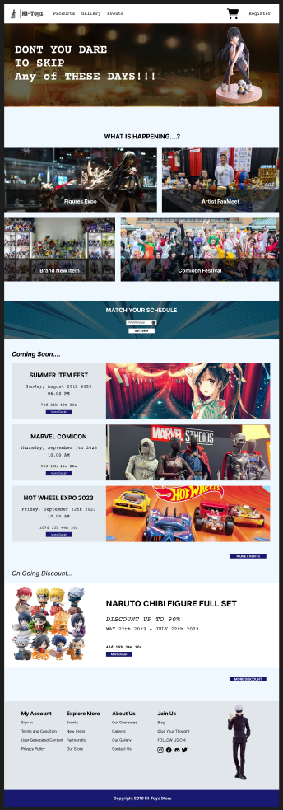
Di Event Page, secara umum berisi informasi mengenai event-event yang ada di HI-Toyz. Design awal setelah header dimulai dengan layout pesan selingan. Di bagian bawahnya terdapat jenis-jenis kategori event yang biasa diadakan di HI-Toyz sehingga user bisa memilih jenis event yang ingin diikuti. Selanjutnya ada pula fitur Match Schedule sehingga user juga bisa memilih event di tanggal-tanggal tertentu. Design dilanjutkan dengan menginformasikan event-event terdekat dan user juga bisa melihat informasinya lebih detail dengan menekan button more detail, atau melihat lebih banyak event dengan menekan button More events. Halaman ini diakhiri dengan informasi mengenai diskon yang sedang berlangsung, menekan tombol More Detail untuk informasi lebih lengkap dan More Discount untuk melihat lebih banyak diskon.

Referensi Media:
    - My Youth Romantic Anime Figure: https://m.media-amazon.com/images/I/61DIe06XMLS._AC_SL1000_.jpg
    - Background: https://i.pinimg.com/originals/17/dc/e4/17dce401c6e179de010c4407f79a3ef4.jpg
    - Figure Expo: https://live.staticflickr.com/3723/18828517204_d143b9fabf_b.jpg
    - Artist FanMeet: https://bloximages.newyork1.vip.townnews.com/guampdn.com/content/tncms/assets/v3/editorial/7/d6/7d6f0f08-21b9-11ed-bbe4-e72ea18ac3d2/6302dbd8a18fd.image.jpg?resize=1396%2C1047
    - New Item: https://www.superherotoystore.com/cdn/shop/articles/c923702091a14bf7aab24de6c887f13f_800x.jpg?v=1653136199
    - Comicon: https://www.nagoyaisnotboring.com/wp-content/uploads/2020/06/WCS2019_Meiji-Mura.jpg
    - Summer: https://i.ytimg.com/vi/GXvlSr794hs/maxresdefault.jpg
    - Marvel: https://www.laughingplace.com/w/wp-content/uploads/2022/07/photos-marvel-costumes-art-and-merchandise-are-on-display-at-san-diego-comic-con-2022.jpeg
    - Hot Wheel: https://wallpapercave.com/wp/wp1860129.jpg
    - Naruto Chibi: https://i.pinimg.com/originals/a0/b6/4a/a0b64ae48a380f5ddd330ea3373b787c.jpg

  - Register Page
Pada Halaman Register Page, untuk membuat akun baru, User perlu memasukkan nama dengan minimal 4 karakter, memilih jenis kelamin, memasukkan tanggal lahir, email yang wajib diakhiri dengan @email.com, dan password dengan jumlah minimal 3 karakter, serta mencentang bagian agreement. Akan ditampilkan pesan apabila salah satu syarat tersebut tidak terpenuhi.

Referensi Media:
    - Nekokara Parade Vanilla Figure: https://m.media-amazon.com/images/I/6159bNSlGRS.jpg
    - Instagram: https://fontawesome.com/47d014a4-1b17-4501-85eb-84935e11cb9e
    - Discord: https://fontawesome.com/c003e1af-4bfc-4e26-af82-791e85994dd5
    - Twitter: https://fontawesome.com/dddbc68d-6c89-474b-bb3b-f02bd3644055
    - Facebook: https://fontawesome.com/80928a75-c924-4052-884d-886c67bdd702

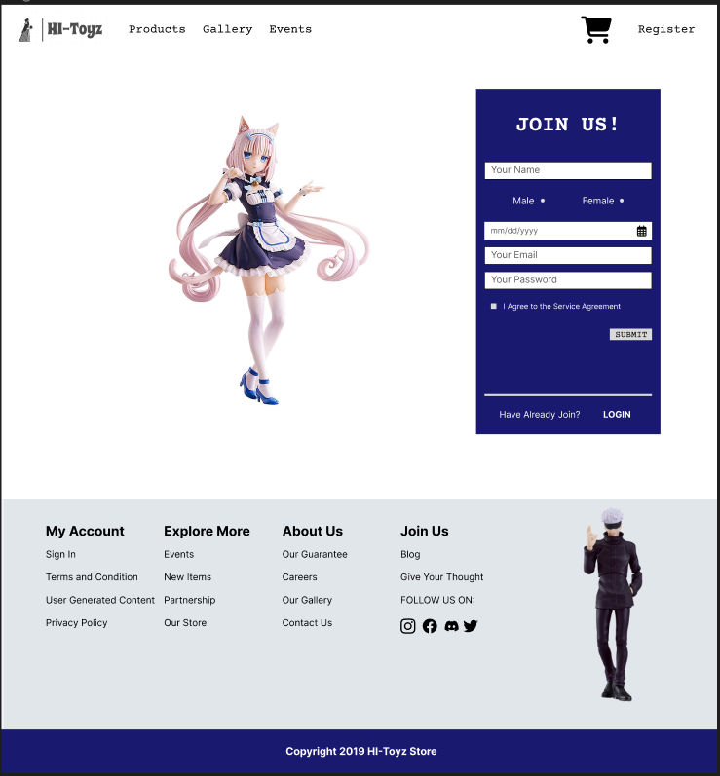

Figma Link: https://www.figma.com/file/0cGPCYdVsj3gPLsEF0ryLU/HCI-AOL-_FIGMA_Michael-Dimas-Chrispradipta_2602132154?type=design&t=6N8fjbxGCH9qqELy-1

